UNDERGRADUATE FINAL YEAR PROJECT REPORT
Department of Mechanical Engineering
NED University of Engineering and Technology

[Title of the Project]

Group Number: ___________ Batch: 20__ – 20__

Group Member Names:

[Name of Student] [Seat Number]
[Name of Student] [Seat Number]
[Name of Student] [Seat Number]
[Name of Student] [Seat Number]

Approved by
……………………………………………………………………………………………...
[Name of Project Advisor]
[Designation of Advisor]
Project Advisor

© NED University of Engineering & Technology. All Rights Reserved – [Month Year]

Author’s Declaration
We declare that we are the sole authors of this project. It is the actual copy of the project that was accepted by our advisor(s) including any necessary revisions. We also grant NED University of Engineering and Technology permission to reproduce and distribute electronic or paper copies of this project.

Signature and Date

..................................
[Name of Student]
[Seat Number]
Signature and Date

..................................
[Name of Student]
[Seat Number]
Signature and Date

..................................
[Name of Student]
[Seat Number]
Signature and Date

..................................
[Name of Student]
[Seat Number]

[Email address] [Email address] [Email address] [Email address]

Statement of Contributions
[Mention here the contributions of each student in the project report work.]

Executive Summary
Write the summary of report here. Limit the summary to 350 words and use single-spacing between lines. It should include the following details:
- Problem statement
- Background information
- Methodology used to solve the problem
- Major findings
- Conclusions
It should give a clear idea to the reader about what is included in the report without providing excessive details. Do not include citations, figures or cross references to tables and figures in the summary.

Acknowledgments
[Write the acknowledgments here. Use single-spacing between lines. You can acknowledge any faculty member, any national or international organization, or sponsor for helping you out in completion of this project. They may have provided you valuable resources in the form of data, personal experience, disciplinary expertise, instruments, or technical support. Ideally it should be one or two short paragraphs.]
Dedication [Optional]
[Write dedication here. You may want to dedicate this work to immediate family members or members of a board or society that works for your cause. Ideally, it should be only one or two lines in length. However, if you do not wish to include a dedication, delete this page. After deleting this page and updating the table of contents, this page will automatically disappear from the table of content. In case, you have decided to delete this page, the table of contents should begin from page v.]
Table of Contents
Author’s Declaration ii
Statement of Contributions iii
Executive Summary iv
Acknowledgments v
Dedication [Optional] vi
Table of Contents vii
List of Figures viii
List of Tables ix
List of Abbreviations x
List of Symbols xi
United Nations Sustainable Development Goals xii
Similarity Index Report xiii
Chapter 1 Introduction 1
1.1 Background Information 1
1.2 Significance and Motivation 1
1.3 Aims and Objectives 1
1.4 Methodology 1
1.5 Report Outline 2
Chapter 2 Literature Review 3
2.1 Introduction 3
2.2 [Title of the Section] 3
2.3 [Title of the Section] 4
2.4 More Sections 4
2.5 Summary 4
Chapter 3 [Name of the Chapter] 5
3.1 Introduction 5
Chapter 4 [Name of the Chapter] 6
4.1 Introduction 6
Chapter 5 Conclusions 7
5.1 Summary 7
5.2 Recommendations for Future Work 7
Appendix A [Title of Appendix] 8
References 9
Glossary [Optional] 10

List of Figures
Figure 1: Trend of Monthly Average High and Low Temperatures in Karachi (Shepherd, 1956) 4

List of Tables
Table 1: Residual Stresses for a Plate 4

List of Abbreviations

FPC | Flat Plate Collector
TSS | Tubular Solar Still
EPBP | Economic Payback Period

List of Symbols
  - Symbols
$$\vec{u}$$ | Velocity Vector $(\frac{m}{s})$
$$T$$ | Temperature $(K)$
$$g$$ | Gravitational Acceleration $\left(=-9.8\frac{m}{s^{2}}\right)$

  - Greek
$$σ$$ | Normal Stresses $(Pa)$
$$ψ$$ | Streamline Function
$$β$$ | Tilt of Plate $\left(degrees °\right)$

United Nations Sustainable Development Goals

The Sustainable Development Goals (SDGs) are the blueprint to achieve a better and more sustainable future for all. They address the global challenges we face, including poverty, inequality, climate change, environmental degradation, peace and justice. There is a total of 17 SDGs as mentioned below. Check the appropriate SDGs related to the project.

☐ No Poverty

☐ Zero Hunger

☐ Good Health and Well being

☐ Quality Education

☐ Gender Equality

☐ Clean Water and Sanitation

☐ Affordable and Clean Energy

☐ Decent Work and Economic Growth

☐ Industry, Innovation and Infrastructure

☐ Reduced Inequalities

☐ Sustainable Cities and Communities

☐ Responsible Consumption and Production

☐ Climate Action

☐ Life Below Water

☐ Life on Land

☐ Peace and Justice and Strong Institutions

☐ Partnerships to Achieve the Goals

Similarity Index Report
Following students have compiled the final year report on the topic given below for partial fulfillment of the requirement for Bachelor’s degree in Mechanical Engineering.

Project Title | _____________________________________________________________
 | _____________________________________________________________

S. No. | Student Name | Seat Number | Signature
1. | ___________________________ | _____________ | _____________
2. | ___________________________ | _____________ | _____________
3. | ___________________________ | _____________ | _____________
4. | ___________________________ | _____________ | _____________

This is to certify that Plagiarism test was conducted on complete report, and overall similarity index was found to be less than 20%, with maximum 5% from single source, as required.
Signature and Date

..................................
[Name of Advisor]
[Plagiarism Test must be conducted on the project report by the project advisor using Turnitin Software, or any other software approved by the university. Project Advisor is required to sign the Plagiarism Certificate if the similarity is found as per rules defined in the guidelines. Plagiarism report must be included (only the first and last page) generated by Turnitin. A sample of the plagiarism test report is provided with the FYP template package.]
[Attach here the first and last page of the plagiarism report generated by Turnitin.]

Introduction

Background Information
A project report usually contains five or six chapters. Chapters should be divided into sections that should be numbered according to their chapter numbers. For instance, the numbering of sections of chapter one should be 1.1, 1.2, 1.3, etc.
The first chapter should be “Introduction” and it should provide the background information related to the project. The first section of the Introduction chapter should be titled “Background Information”. While the other sections should be “Significance and Motivation”, “Aims and Objectives”, “Methodology” and “Report Outline/Scope” of the Project. It should inform the readers what you did in the project, why you did it, and how you achieved it. This chapter provides a broad overview on what is discussed in the report.

Significance and Motivation
The second section of the chapter one should be “Significance and Motivation”. It should include the importance of the project and its benefits.
Subsections should have numbering in accordance with its chapter and section number. For example, the numbering of subsections in section two of chapter one should be like 1.2.1, 1.2.2, 1.2.3, etc. It is not recommended to have only a single subsection in a section.

Aims and Objectives
The third section of the chapter one should be “Aims and Objectives”.

Methodology
The fourth section of the chapter one should be “Methodology”. It should include the details of the methodology that you have used to solve the problem.

Report Outline
The fifth section of the chapter one should be “Report Outline”. It should include the scope of the project and explain the general outline of the report by highlighting the content that is covered in different chapters and sections.
Kindly include more sections in the Introduction chapter if you prefer.

Literature Review

Introduction
Except for the Introduction chapter (first chapter) and the Conclusion chapter (last chapter), all other chapters should have first section titled “Introduction” and last section titled “Summary/Conclusions”. In Introduction sections, discuss the content of chapters such that the readers will have an idea about what is discussed in the chapters. This allows the readers to know in advance if the chapter is relevant to their interests. On the other hand, the Summary sections discuss what has been achieved in the chapters. Write the Summary sections by keeping in mind that many readers do not have time to read the complete chapters; therefore, they only read Summary sections to get an overview. Consequently, include the most important achievements and aspects in these sections and use past tense to write Summary sections.

The goal of this chapter is you discuss how your work is different from the work already done in the field. You should present a critical review on the past work on your topic. This chapter will in return help students to gather updated knowledge on the project and this will enable them to understand the limitations of previous work done on your topic.

[Title of the Section]
A sample graph is shown in the Figure 1. Always use the “Insert Caption” option to insert the figure label and numbering automatically. This will also automatically update them in the List of Figures. Captions of figures should be given on the bottom of the figures. To refer to a figure in the text go to References in the Ribbon, then click on Cross-reference, then select Figure in Reference type, then select Only label and number in Insert reference to.
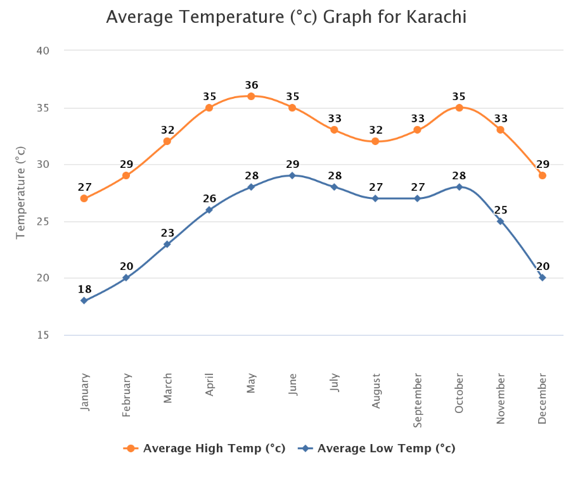
Figure 1: Trend of Monthly Average High and Low Temperatures in Karachi (Shepherd, 1956)

[Title of the Section]
A sample table is shown in the Table 1. Always use the “Insert Caption” option to insert the figure label and numbering automatically. This will also automatically update them in the List of Figures. Captions of tables should be given on the top of the tables. To refer to a table in the text go to References in the Ribbon, then click on Cross-reference, then select Table in Reference type, then select Only label and number in Insert reference to.
Table 1: Residual Stresses for a Plate
Orientation | $$σ_{x}(MPa)$$ | $$σ_{y}(MPa)$$ | $$τ_{xy}(MPa)$$ | $$τ_{xz}(MPa)$$ | $$τ_{yz}(MPa)$$
$$0°$$ | -0.282 | -0.143 | 0 | 0 | 0
$$90°$$ | 0.282 | 0.143 | 0 | 0 | 0

More Sections
Include sections as appropriate to your literature review.

Summary
Last section of each chapter should be Summary or Conclusion.

[Name of the Chapter]

Introduction
Include more chapters as appropriate to your project. All chapters should start from a new page. The middle chapters should discuss your work on the project. Some famous headings for these chapters are Design and Calculations, Modeling and Simulations, Fabrication Work, Data Acquisition and Analysis, Comparison of Methods, Results, Discussion/Interpretation of Results, etc.

[Name of the Chapter]

Introduction
More chapters.

Conclusions

Summary
The last chapter should be “Conclusions”. It is ideally the fourth or fifth section of the report. This chapter should include the aims and objectives of the project. It should also summarize the important points in the previous chapters, and the findings and achievements of your project. If possible, write some recommended future work on the project based in your conclusions. Therefore, the last section of this chapter should ideally be “Recommendations”. For example, you may provide recommendations by discussing constraints of your project and ideas to eliminate them. You may also highlight other possible investigations to improve the efficiency of your project. Use present perfect tense to write the conclusions. The recommended two sections for the Conclusions chapter are “Summary” and “Recommendations for Future Work”.
Do not use cross referencing, external references, or footnotes in the Conclusions chapter. Make it a stand-alone chapter.

Recommendations for Future Work
Write details here.
- [Title of Appendix]
Include appendices, if applicable. Appendices should include the information that is not the primary part of the main body of the project report. This means that if this information is removed from the main body, it would not negatively affect the flow of ideas in the main body of the report. For example, it may include long computer programming codes while keeping a flow chart of the code in the main body of the report. It may also include lengthy numerical data while keeping their graphs in the main body of the report.
If the project report has only one appendix, then the label of this chapter should be “Appendix” (not “Appendix A”). To cite an appendix in the text, write full title of the appendix that is “Appendix A”, “Appendix B”, etc. Each appendix should start from a new page and should also include a short description of what is included in that appendix.

References
Shepherd, D. G. (1956). Performance of one-row tube coils with thin-plate fins, low velocity forced convection. Heating, Piping Air Cond, 28, 137-144.

Glossary [Optional]
Term | Definition | [Page at which it first appeared]
Azimuth | angle between North, measured clockwise around the observer's horizon and sun | Pg. 1
Zenith | an imaginary point directly above the observer/system, complement of altitude angle | Pg. 5

